**SOUND CONTROLLED LIGHT SWITCH**

**Neag Dragoș-Ion**

Contents

1. Introduction 3

2. Hardware 3

a. Sensors 3

b. Actuators 3

3. Assembly 4

4. Model 5

5. Bibliography 5

# Introduction

The project I decided to implement is a mechanical light switcher, controlled by clapping. I think anybody at some point heard of this idea and wished that one day they will own such a device. Personally, I never owned a device meant to make your house smarter, and I thought it would be extremely practical and useful.

# Hardware

## Sensors

The only sensor I use is a High Sensitivity Microphone Module. It is composed of three pins – GND, Vcc and Out. The output is analogical, and the values are numbers that increase along with the sound intensity.

The sensor outputs a noisy voltage, so to use this microphone I averaged a hundred samples in order to be more meaningful. After testing the sensor, I arrived at the conclusion that a sound above the value 40 is high enough to be interpreted as a clap and so the servo motor can be activated.

## Actuators

In order to toggle the light, switch on and off, after an output from the microphone high enough to mean is a clap is detected, an actuator is required, and for that I used the Tower Pro MG995 servo motor. The motor can sustain 11 kg and is able to perform rotations up to 180°.

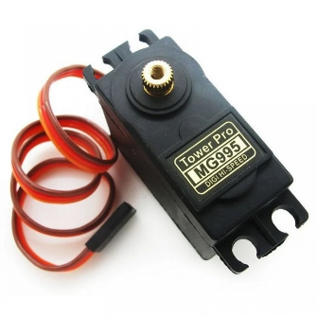 The idea is simple, if the state of the switch is off, then after a clap the servo will rotate at 180 degrees to close the switch. Else, if the switch is on, it will rotate at only 60 degrees, so the switches are brought down.

For this implementation to work, I use the Servo.h library.

# Assembly

Although the circuit was working, I required some material to physically move the light switches up and down. For that, two plates of plastic were required. One planted into a holder, and one that can move up and down.

The servo motor is screwed to the first piece, while the servo horn will be held by a screw and a nut in a hole that allows it to move up and down if it is fixed into another screw.

# Chart Description automatically generated with low confidenceModel

# Bibliography

<https://create.arduino.cc/projecthub/Mahmoud_Tolba/how-to-control-your-light-switch-from-your-smartphone-510ca9>

<https://content.instructables.com/ORIG/FS4/X37V/FPWWRDFX/FS4X37VFPWWRDFX.pdf>

<https://www.teachmemicro.com/arduino-microphone/>

<https://howtomechatronics.com/how-it-works/how-servo-motors-work-how-to-control-servos-using-arduino/>